

Spotify

Musical

Analysis



This is an exploratory project on Spotify data which is further explained much more. In this project the use of analytical software likes MS excel which is used for the basic understanding & cleaning of the data then the whole data is carry forward to the jupyter when python came in role the use f python libraries like pandas used for the data extraction , matplotlib and seaborn which is used for the plotting of extracted data.

INTRODUCTION

Data Set Used ?

This data contains the information of tracks , artists name , album name, duration MS , keys , genres, explicit , danceability , energy , popularity of each and every track I have also added a column of popularity criteria which has most popular , popular , known , least popular tracks according to popularity given and some mor data is there which will help us in our analysis .

This data is used for the analysis of ;

* **Classification** purposes based on audio features and available genres.
* Having a look on the popularity of tracks on different basis.
* This data is also used for the classification of genres and artists on different basis.

This the list of columns in our table .

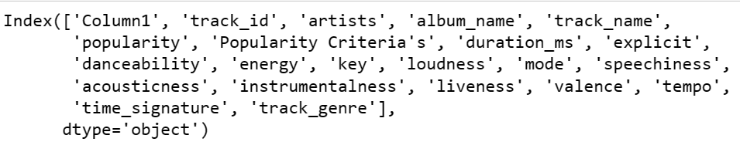

now let us see the information of data we have

# Column Non-Null Count Dtype

--- ------ -------------- -----

0 Column1 114000 non-null int64

1 track_id 114000 non-null object

2 artists 114000 non-null object

3 album_name 114000 non-null object

4 track_name 114000 non-null object

5 popularity 114000 non-null int64

6 Popularity Criteria's 114000 non-null object

7 duration_ms 114000 non-null int64

8 explicit 114000 non-null bool

9 danceability 114000 non-null float64

10 energy 114000 non-null float64

11 key 114000 non-null int64

12 loudness 114000 non-null float64

13 mode 114000 non-null int64

14 speechiness 114000 non-null float64

15 acousticness 114000 non-null float64

16 instrumentalness 114000 non-null float64

17 liveness 114000 non-null float64

18 valence 114000 non-null float64

19 tempo 114000 non-null float64

20 time_signature 114000 non-null int64

21 track_genre 114000 non-null object

PROBLEM STATEMENTS



1. % of songs VS popularity criteria
2. Top 5 artist (No . of songs ).
3. Top 5 artist (acc. Popularity )
4. Top 5 loudest tracks
5. Artist with most danceability
6. Top 10 instrumental tracks
7. Most listen key song
8. Top 5 most popular genres

This Analysis of data we have 4 popularity criteria these are most popular song , popular song , known songs , least popular songs which are categorized on the basis of popularity column.

I have used pie chart with explode which is telling us the least popular song % .



% Song VS Popularity Criteria

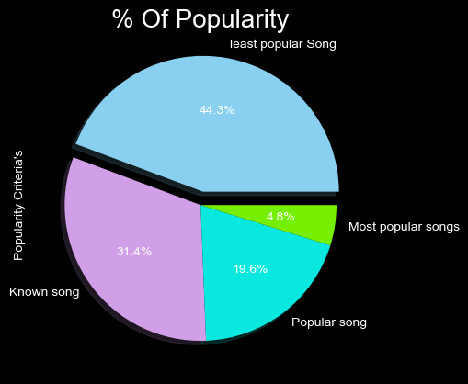

Top 5 Artists (No. Of Songs)

Now in this we want to know the Top 5 artists having most numbers of songs . this will tell us the demand of songs and supply by the artists.

The Beatles 279

George Jones 271

Stevie Wonder 236

Linkin Park 224

Ella Fitzgerald 222

These are the top 5 artist with the total number of songs.

Top 5 Artists (No. Of Popularity)

This analysis will include the popularity of the artists according to the sum rated popularity of the each and every artists . which basically help us in defining the artist popularity loved by people. The list of expected people are given below.

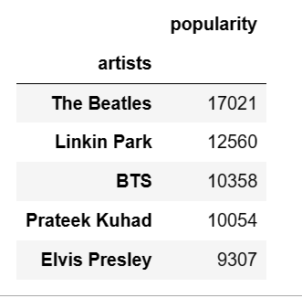

Now lets have graphical representation of the visual data.

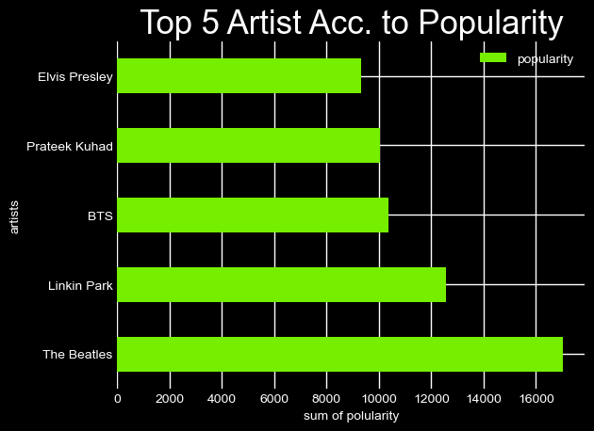

Top 5 Loudest Tracks

In our data we have the tracks and loudness column now we want to know the top 5 loudest of them.

Here is the list of top 5 loudest tracks .

Loudness in positive which means the loudness is more than the standard value.

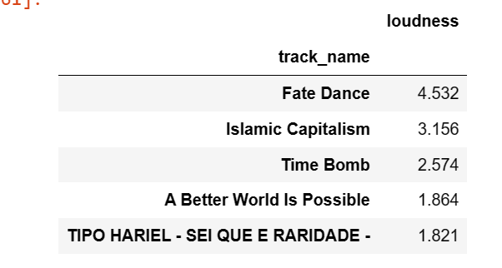

Now lets have the graphical representation of the tabular data.

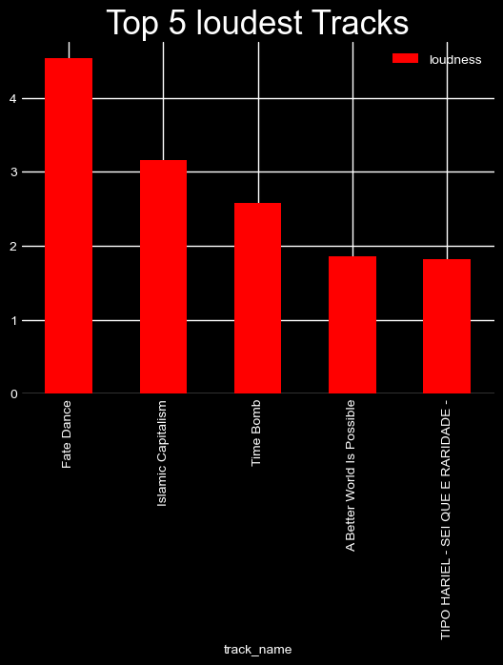

Artist with most danceability

Now in this analysis we wanted those artists who are have the songs which have most danceability factor means those artist who are making danceable songs.

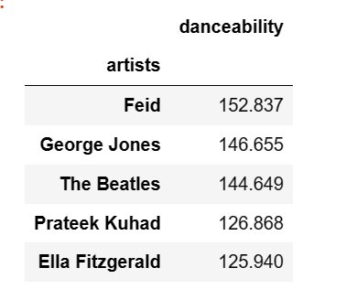

Now have visual representation of the above tabular data must be.

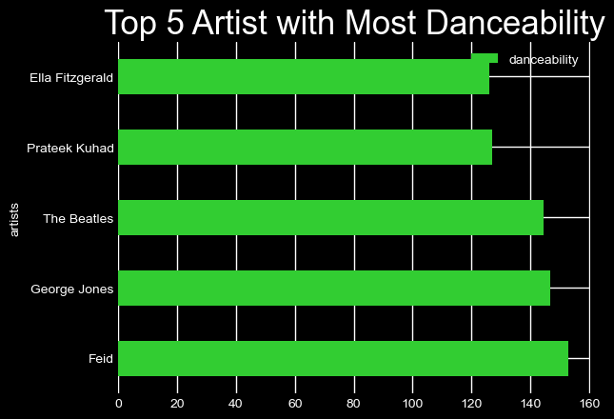

Top 10 Instrumental Tracks

In this we Just wanted to know abut the top10 istrumental tracks in our spotify data sets .

This list is showing us the result to top10 instrumental tracks .

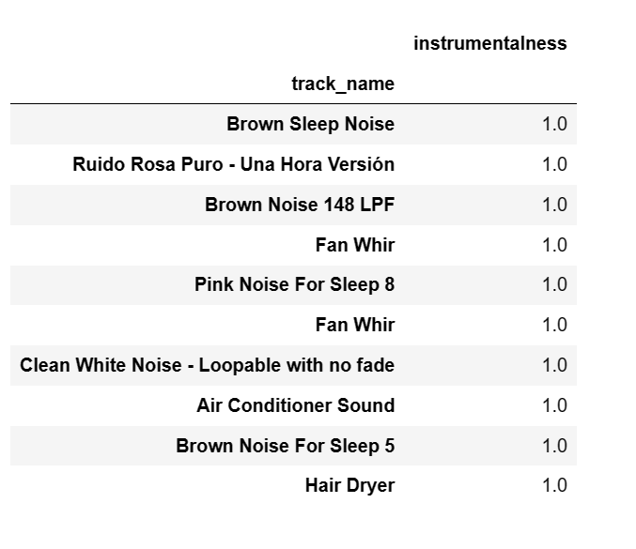

Most Listen Key

In our dataset we have 12 keys so we wanted to know that which key song is listen more in numbers . so we have grouped by the keys .

Here is the expected list.

Keys No. of songs

7 13245

0 13061

2 11644

9 11313

1 10772

5 9368

11 9282

4 9008

6 7921

10 7456

8 7360

3 3570

Top 5 Most Popular Genre’s

In our dataset we have 114 different types of genres so we have to know that which genre is most popular according to the popularity rating we have .

So here is the Top 5 most popular genres list.

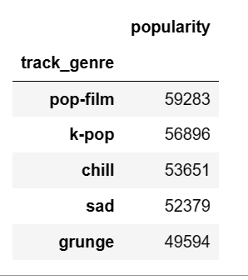

Now have visual representation of the above tabular data must be a pie chart .

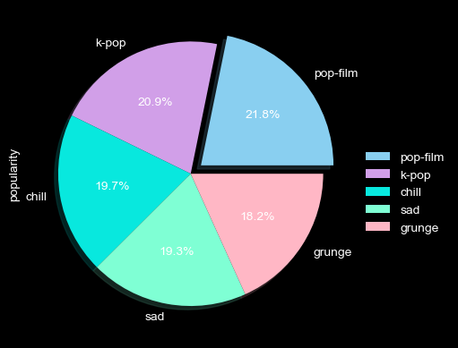

CONCLUSION



* According to the pie chart the least popular songs are 44.3% in our Spotify data which should be reduced . and the most popular are just 4.8% which should be increased as soon as possible.
* Top Artist in making No. of songs are Beatless with 279 songs followed by George jones with 271 songs. These are doing good in making songs
* Beatless is the top artist with total of 17021 Popularity among people so Beatless is the most liked by people , he is making most number of songs as well , linkin park is the second most liked artist after beatless.
* Fate Dance is the most loudest music track we have in our Spotify dataset .
* Feid the artist who is making those songs which makes the audience Dance with total of 152.837 Danceability factor , followed by George Jone and Beatless too.
* The key 7 having most number of songs according to the data set with 13245 no of songs & key 3 is havig least No. of songs i.e. 3570 songs.
* POP films is the most popular genre with total of 59283 poplarity , followed by K-POP having 56896 poplarity.